Spring Declarative Transactions
Download Source
×This tutorial requires prior knowledge of Spring Annotations and Spring Jdbc concepts. Readers are advised to go through JdbcTemplate Tutorial and Spring Annotations tutorial before proceeding.
In Spring's terminology, transaction management can be done in the following ways:
Type | Definition | Way of implementing
Declarative Transactions | When you do something outside your business logic i.e with some simple configuration you apply a common functionality across all your code. | Using @Transactional annotation
Declarative Transactions |  | Using xml based aop configuration to have a transactional advice
Programmatic Transactions | When you add code some functionality by urself so that you could control each and everything by urself. This usually mixes the unrelated functionality in your business logic. | Using PlatformTransactionManager
Programmatic Transactions |  | Using TransactionTemplate

Spring Declarative transaction management

1. Annotation style transaction
To use the annotation style transaction management all you have to do is to add a 3 simple bean configuration in your xml file i.e:
- <context:annotation-config/>: Tells Spring framework to read @Transactional annotation
- <tx:annotation-driven/>: Automatically adds transaction support which eventually wraps your code in transaction scope
- Initializing DataSourceTransactionManager bean

Xml configuration for enabling @Transactional annotation
- <context:annotation-config/>
- <!-- Add this tag to enable annotations transactions -->
- <tx:annotation-driven transaction-manager="transactionManager"/>
- <bean id="transactionManager"
- class="org.springframework.jdbc.datasource.DataSourceTransactionManager">
- <property name="dataSource" ref="dataSource"></property>
- </bean>
- <bean id="dataSource" class="org.apache.commons.dbcp.BasicDataSource">
- <property name="driverClassName" value="com.mysql.jdbc.Driver"></property>
- <property name="url" value="jdbc:mysql://localhost:3306/apu"></property>
- <property name="username" value="root"></property>
- <property name="password" value=""></property>
- </bean>

- <bean id="jdbcTemplate" class="org.springframework.jdbc.core.JdbcTemplate">
- <property name="dataSource" ref="dataSource"></property>
- </bean>
- <bean id="userDao" class="springjdbc.transactions.declarative.annotations.AnnotatedUserDao">
- <property name="jdbcTemplate" ref="jdbcTemplate"></property>
- </bean>

NOTE! Dont forget to change the username and password in the above bean accordingly.

Using @Transaction in code
Following is a Dao class that uses @Transactional annotation to add declarative transactions. @Transactional at class level wraps all method in transaction scope. The @Transactional annotation has several properties like readOnly, isolation, propagation,rollbackFor, noRollbackFor etc that can be used to control how one transaction behaves and communicate with other transactions. We use readOnly property of @Transactional to mark the method eligible only for making select queries when@Transactional(readOnly=true) and update, insert queries in case @Transactional(readOnly=false). By default readOnly is false, which means you can perform all the CRUD operations, change it to true will allow only select statements to be executed. Other very useful properties of @Transactional is rollbackFor and noRollbackFor. By default Spring rolls back the transaction for exceptions of type RuntimeException or unchecked exceptions.

AnnotatedUserDao.java
- /**
- * @author achauhan
- */
- @Transactional
- public class AnnotatedUserDao implements IUserDao {
- private JdbcTemplate jdbcTemplate;

- public void setJdbcTemplate(JdbcTemplate jdbcTemplate) {
- this.jdbcTemplate = jdbcTemplate;
- }

- public void deleteUser(int uid) {
- String delQuery = "delete from users where id = ?";
- jdbcTemplate.update(delQuery, new Object[] { uid });

- }

- public int insertUser(User user) {
- String inserQuery = "insert into users (username, password, enabled , id) values (?, ?, ?, ?) ";
- Object[] params = new Object[] { user.getUserName(),
- user.getPassword(), user.isEnabled(), user.getId() };
- int[] types = new int[] { Types.VARCHAR, Types.VARCHAR, Types.BIT,
- Types.INTEGER };
- int number = jdbcTemplate.update(inserQuery, params, types);
- return number;
- }

- // override the class level transactional behaviour for select method
- @Transactional(readOnly = true)
- public User selectUser(int uid) {
- // for all the RuntimeExceptions the transactions will be automatically
- // rolled back
- throw new RuntimeException("A runtime exception");

- }

- public int updateUser(User user) throws Exception {
- throw new Exception("A checked exception");
- }

IMPORTANT! The above methods selectUser and updateUser are intentionally left blank so that users could understand the rollback behaviour of transactions
The selectUser method throws a RuntimeException. When Spring notices that the method is throwing a RuntimeException it automatically rolls back the transaction. Contrary to this is the call to updateUser which throws a checked exception. When spring sees that exception is checked exception, it proceeds to commit the transactions. To get a deep understanding of what Spring is doing behind the scenes, you can switch the log4j level to trace and check out the console.

Overriding default rollback behaviour
To override the default rollback behaviour, we use the rollbackFor and noRollbackFor properties of @Transactional. So taking the example of selectUser method which throws a RuntimeException. To tell the Spring that it should not roll back the transaction in this case, we will write :
@Transactional(readOnly = true,noRollbackFor=RuntimeException.class)
Now if you call the selectUser method, following trace is seen on console.
Following is the comparison of console output with default rollback setting and with overriden rollback setting for selectUser method call.
@Transactional(readOnly = true)
- 20:57:29,141 TRACE [TransactionInterceptor] Getting transaction for [springjdbc.IUserDao.selectUser]
- 20:57:29,142 TRACE [TransactionInterceptor] Completing transaction for [springjdbc.IUserDao.selectUser] after exception: java.lang.RuntimeException: A runtime exception
- 20:57:29,142 TRACE [RuleBasedTransactionAttribute] Applying rules to determine whether transaction should rollback on java.lang.RuntimeException: A runtime exception
- 20:57:29,142 TRACE [RuleBasedTransactionAttribute] Winning rollback rule is: null
- 20:57:29,142 TRACE [RuleBasedTransactionAttribute] No relevant rollback rule found: applying default rules
- 20:57:29,142 DEBUG [DataSourceTransactionManager] Initiating transaction rollback

@Transactional(readOnly = true,noRollbackFor=RuntimeException.class)
- 21:25:07,694 TRACE [TransactionInterceptor] Getting transaction for [springjdbc.IUserDao.selectUser]
- 21:25:07,695 TRACE [TransactionInterceptor] Completing transaction for [springjdbc.IUserDao.selectUser] after exception: java.lang.RuntimeException: A runtime exception
- 21:25:07,695 TRACE [RuleBasedTransactionAttribute] Applying rules to determine whether transaction should rollback on java.lang.RuntimeException: A runtime exception
- 21:25:07,696 TRACE [RuleBasedTransactionAttribute] Winning rollback rule is: NoRollbackRuleAttribute with pattern [java.lang.RuntimeException]
- 21:25:07,697 DEBUG [DataSourceTransactionManager] Initiating transaction commit

Our test class is similar to the one we used in JdbcTemplate tutorial.

2. Xml based Transaction configuration
To use the Xml based Spring Transaction management all you have to do is to add 3 simple bean configuration in your xml file i.e:
- Initializing DataSourceTransactionManager bean
- <tx:advice />: Configures the transaction advice. In this advice we configure various transaction properties for different methods. So what was earlier written as @Transactional(readOnly = true) will now be written as <tx:method name="select*" read-only="true" />.
- <aop:config/>: Final step is to apply the transaction advice using aop configuration.
- <context:annotation-config/>
- <bean id="transactionManager"
- class="org.springframework.jdbc.datasource.DataSourceTransactionManager">
- <property name="dataSource" ref="dataSource"></property>
- </bean>
- <tx:advice id="txAdvice" transaction-manager="transactionManager">
- <tx:attributes>
- <tx:method name="select*" read-only="true" />
- <tx:method name="*" />
- </tx:attributes>
- </tx:advice>
- <aop:config>
- <aop:pointcut id="userDaoTxPointcut" expression="execution(* springjdbc.IUserDao.*(..))" />
- <aop:advisor advice-ref="txAdvice" pointcut-ref="userDaoTxPointcut" />
- </aop:config>
- <bean id="dataSource" class="org.apache.commons.dbcp.BasicDataSource">
- <property name="driverClassName" value="com.mysql.jdbc.Driver"></property>
- <property name="url" value="jdbc:mysql://localhost:3306/apu"></property>
- <property name="username" value="root"></property>
- <property name="password" value=""></property>
- </bean>
- <bean id="jdbcTemplate" class="org.springframework.jdbc.core.JdbcTemplate">
- <property name="dataSource" ref="dataSource"></property>
- </bean>
- <bean id="userDao" class="springjdbc.transactions.declarative.xml.UserDao">
- <property name="jdbcTemplate" ref="jdbcTemplate"></property>
- </bean>

Spring MVC @ExceptionHandler Example
By mkyong | October 7, 2013 | Viewed : 145,311 times +956 pv/w
In this tutorial, we show you how to do exception handling in Spring MVC frameworks. Normally, we use @ExceptionHandler to decide which “view” should be returned back if certain exception is raised.
P.S This @ExceptionHandler class is available since Spring 3.0

1. Project Structure
Review the project directory structure, a standard Maven project.
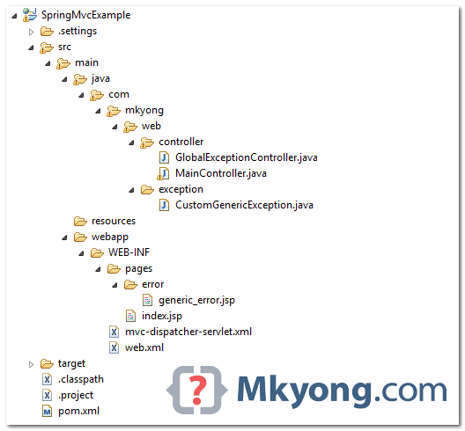

2. Custom Exception
A custom exception, with custom error code and error description.
CustomGenericException.java
package com.mkyong.web.exception;

public class CustomGenericException extends RuntimeException {

private static final long serialVersionUID = 1L;

private String errCode;
private String errMsg;

public String getErrCode() {
return errCode;
}

public void setErrCode(String errCode) {
this.errCode = errCode;
}

public String getErrMsg() {
return errMsg;
}

public void setErrMsg(String errMsg) {
this.errMsg = errMsg;
}

public CustomGenericException(String errCode, String errMsg) {
this.errCode = errCode;
this.errMsg = errMsg;
}

}

3. Spring Controller
A Spring controller, review the execution-flows below :
- If user provide a /error request, it throws “CustomGenericException”, and the handleCustomException() method will be fired.
- If user provide a /io-error request, it throws “IOException”, and the handleAllException() method will be fired.
MainController.java
package com.mkyong.web.controller;

import java.io.IOException;
import org.springframework.stereotype.Controller;
import org.springframework.web.bind.annotation.ExceptionHandler;
import org.springframework.web.bind.annotation.PathVariable;
import org.springframework.web.bind.annotation.RequestMapping;
import org.springframework.web.bind.annotation.RequestMethod;
import org.springframework.web.servlet.ModelAndView;

import com.mkyong.web.exception.CustomGenericException;

@Controller
public class MainController {

@RequestMapping(value = "/{type:.+}", method = RequestMethod.GET)
public ModelAndView getPages(@PathVariable("type") String type)
throws Exception {

if ("error".equals(type)) {
// go handleCustomException
throw new CustomGenericException("E888", "This is custom message");
} else if ("io-error".equals(type)) {
// go handleAllException
throw new IOException();
} else {
return new ModelAndView("index").addObject("msg", type);
}

}

@ExceptionHandler(CustomGenericException.class)
public ModelAndView handleCustomException(CustomGenericException ex) {

ModelAndView model = new ModelAndView("error/generic_error");
model.addObject("errCode", ex.getErrCode());
model.addObject("errMsg", ex.getErrMsg());

return model;

}

@ExceptionHandler(Exception.class)
public ModelAndView handleAllException(Exception ex) {

ModelAndView model = new ModelAndView("error/generic_error");
model.addObject("errMsg", "this is Exception.class");

return model;

}

}

4. JSP Pages
pages/index.jsp
<%@taglib prefix="c" uri="http://java.sun.com/jsp/jstl/core"%>
<html>
<body>
<h2>Spring MVC @ExceptionHandler Example</h2>

<c:if test="${not empty msg}">
<h2>${msg}</h2>
</c:if>

</body>
</html>
pages/error/generic_error.jsp
<%@taglib prefix="c" uri="http://java.sun.com/jsp/jstl/core"%>
<html>
<body>

<c:if test="${not empty errCode}">
<h1>${errCode} : System Errors</h1>
</c:if>

<c:if test="${empty errCode}">
<h1>System Errors</h1>
</c:if>

<c:if test="${not empty errMsg}">
<h2>${errMsg}</h2>
</c:if>

</body>
</html>

5. Testing
Review following 3 test cases :
1. http://localhost:8080/SpringMvcExample/anything
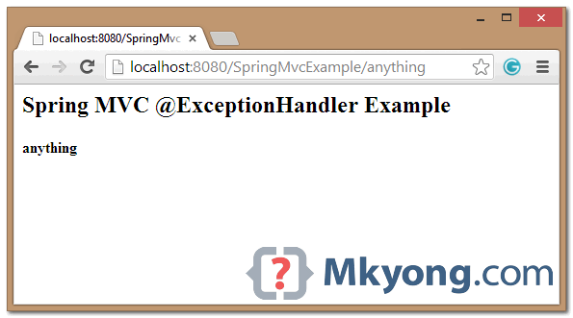
2. http://localhost:8080/SpringMvcExample/error
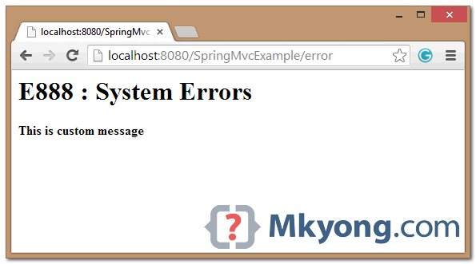
3. http://localhost:8080/SpringMvcExample/io-error
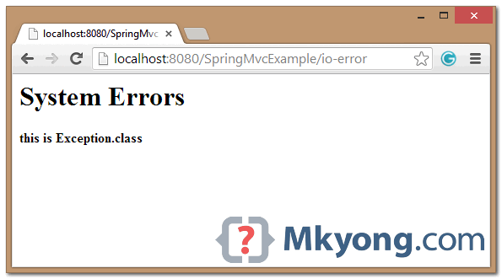

6. @ControllerAdvice Example
The above @ExceptionHandler example is only apply to a single controller, to apply it globally (all controllers), annotate a class with @ControllerAdvice.
GlobalExceptionController.java
package com.mkyong.web.controller;

import org.springframework.web.bind.annotation.ControllerAdvice;
import org.springframework.web.bind.annotation.ExceptionHandler;
import org.springframework.web.servlet.ModelAndView;
import com.mkyong.web.exception.CustomGenericException;

@ControllerAdvice
public class GlobalExceptionController {

@ExceptionHandler(CustomGenericException.class)
public ModelAndView handleCustomException(CustomGenericException ex) {

ModelAndView model = new ModelAndView("error/generic_error");
model.addObject("errCode", ex.getErrCode());
model.addObject("errMsg", ex.getErrMsg());

return model;

}

@ExceptionHandler(Exception.class)
public ModelAndView handleAllException(Exception ex) {

ModelAndView model = new ModelAndView("error/generic_error");
model.addObject("errMsg", "this is Exception.class");

return model;

}

}
Following is the content of Student.java file:
package com.tutorialspoint;

public class Student {
private Integer age;
private String name;
private Integer id;

public void setAge(Integer age) {
this.age = age;
}
public Integer getAge() {
return age;
}

public void setName(String name) {
this.name = name;
}
public String getName() {
return name;
}

public void setId(Integer id) {
this.id = id;
}
public Integer getId() {
return id;
}
}
Following is the content of SpringException.java file:
package com.tutorialspoint;

public class SpringException extends RuntimeException{
private String exceptionMsg;

public SpringException(String exceptionMsg) {
this.exceptionMsg = exceptionMsg;
}

public String getExceptionMsg(){
return this.exceptionMsg;
}

public void setExceptionMsg(String exceptionMsg) {
this.exceptionMsg = exceptionMsg;
}
}
Following is the content of StudentController.java file. Here you need to annotate a service method using @ExceptionHandler where you can specify one or more exceptions to be handled. If you are specifying more than one exceptions then you can use comma separated values.
package com.tutorialspoint;

import org.springframework.stereotype.Controller;
import org.springframework.web.bind.annotation.ExceptionHandler;
import org.springframework.web.bind.annotation.ModelAttribute;
import org.springframework.web.bind.annotation.RequestMapping;
import org.springframework.web.bind.annotation.RequestMethod;
import org.springframework.web.servlet.ModelAndView;
import org.springframework.ui.ModelMap;

@Controller
public class StudentController {

@RequestMapping(value = "/student", method = RequestMethod.GET)
public ModelAndView student() {
return new ModelAndView("student", "command", new Student());
}

@RequestMapping(value = "/addStudent", method = RequestMethod.POST)
@ExceptionHandler({SpringException.class})
public String addStudent( @ModelAttribute("HelloWeb")Student student,
ModelMap model) {

if(student.getName().length() < 5 ){
throw new SpringException("Given name is too short");
}else{
model.addAttribute("name", student.getName());
}

if( student.getAge() < 10 ){
throw new SpringException("Given age is too low");
}else{
model.addAttribute("age", student.getAge());
}
model.addAttribute("id", student.getId());
return "result";
}
}
Following is the content of Spring Web configuration file web.xml
<web-app id="WebApp_ID" version="2.4"
xmlns="http://java.sun.com/xml/ns/j2ee"
xmlns:xsi="http://www.w3.org/2001/XMLSchema-instance"
xsi:schemaLocation="http://java.sun.com/xml/ns/j2ee
http://java.sun.com/xml/ns/j2ee/web-app_2_4.xsd">

<display-name>Spring Exception Handling</display-name>

<servlet>
<servlet-name>HelloWeb</servlet-name>
<servlet-class>
org.springframework.web.servlet.DispatcherServlet
</servlet-class>
<load-on-startup>1</load-on-startup>
</servlet>

<servlet-mapping>
<servlet-name>HelloWeb</servlet-name>
<url-pattern>/</url-pattern>
</servlet-mapping>

</web-app>
Following is the content of another Spring Web configuration file HelloWeb-servlet.xml
<beans xmlns="http://www.springframework.org/schema/beans"
xmlns:context="http://www.springframework.org/schema/context"
xmlns:xsi="http://www.w3.org/2001/XMLSchema-instance"
xsi:schemaLocation="
http://www.springframework.org/schema/beans
http://www.springframework.org/schema/beans/spring-beans-3.0.xsd
http://www.springframework.org/schema/context
http://www.springframework.org/schema/context/spring-context-3.0.xsd">

<context:component-scan base-package="com.tutorialspoint" />

<bean class="org.springframework.web.servlet.view.InternalResourceViewResolver">
<property name="prefix" value="/WEB-INF/jsp/" />
<property name="suffix" value=".jsp" />
</bean>

<bean class="org.springframework.web.servlet.handler.
SimpleMappingExceptionResolver">
<property name="exceptionMappings">
<props>
<prop key="com.tutorialspoint.SpringException">
ExceptionPage
</prop>
</props>
</property>
<property name="defaultErrorView" value="error"/>
</bean>

</beans>
Here you specified ExceptionPage as an exception view in case SpringException occurs, if there is any other type of exception then a generic view error will take place.
Following is the content of Spring view file student.jsp:
<%@taglib uri="http://www.springframework.org/tags/form" prefix="form"%>
<html>
<head>
<title>Spring MVC Exception Handling</title>
</head>
<body>

<h2>Student Information</h2>
<form:form method="POST" action="/HelloWeb/addStudent">
<table>
<tr>
<td><form:label path="name">Name</form:label></td>
<td><form:input path="name" /></td>
</tr>
<tr>
<td><form:label path="age">Age</form:label></td>
<td><form:input path="age" /></td>
</tr>
<tr>
<td><form:label path="id">id</form:label></td>
<td><form:input path="id" /></td>
</tr>
<tr>
<td colspan="2">
<input type="submit" value="Submit"/>
</td>
</tr>
</table>
</form:form>
</body>
</html>
Following is the content of Spring view file error.jsp:
<html>
<head>
<title>Spring Error Page</title>
</head>
<body>

<p>An error occured, please contact webmaster.</p>

</body>
</html>;
Following is the content of Spring view file ExceptionPage.jsp. Here you will access the exception instance via ${exception}.
<%@taglib uri="http://www.springframework.org/tags/form" prefix="form"%>
<html>
<head>
<title>Spring MVC Exception Handling</title>
</head>
<body>

<h2>Spring MVC Exception Handling</h2>

<h3>${exception.exceptionMsg}</h3>

</body>
</html>
Following is the content of Spring view file result.jsp:
<%@taglib uri="http://www.springframework.org/tags/form" prefix="form"%>
<html>
<head>
<title>Spring MVC Form Handling</title>
</head>
<body>

<h2>Submitted Student Information</h2>
<table>
<tr>
<td>Name</td>
<td>${name}</td>
</tr>
<tr>
<td>Age</td>
<td>${age}</td>
</tr>
<tr>
<td>ID</td>
<td>${id}</td>
</tr>
</table>
</body>
</html>
Finally, following is the list of Spring and other libraries to be included in your web application. You simply drag these files and drop them inWebContent/WEB-INF/lib folder.
- commons-logging-x.y.z.jar
- org.springframework.asm-x.y.z.jar
- org.springframework.beans-x.y.z.jar
- org.springframework.context-x.y.z.jar
- org.springframework.core-x.y.z.jar
- org.springframework.expression-x.y.z.jar
- org.springframework.web.servlet-x.y.z.jar
- org.springframework.web-x.y.z.jar
- spring-web.jar
Once you are done with creating source and configuration files, export your application. Right click on your application and use Export > WAR File option and save your HelloWeb.war file in Tomcat's webapps folder.
Now start your Tomcat server and make sure you are able to access other web pages from webapps folder using a standard browser. Now try to access the URL http://localhost:8080/HelloWeb/student. If everything is fine with your Spring Web Applicationand, you should see the following result :
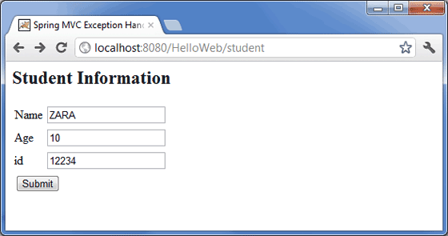
Enter the values as shown above and click submit buttom. If everything is fine with your Spring Web Application, you should see the following result:
